LAB EXPERIMENT RECORD
SET 5: Website Analytics
Department | AI&DS
Course Code / Course Name | DSA0602 / Data Handling and Visualization
Experiment | Data Visualization using R
Name | DEVAMADA HEMASREE
Register Number | 192524114
Date | 01 OCTOBER 2026
Day | THURSDAY

SET 5: Website Analytics
Aim: To visualize website traffic data using a line chart, bar chart, and stacked area chart in R, and to build an interactive dashboard using Tableau.
Dataset: Website Traffic
Date | Page Views | Click-through Rate
2023-01-01 | 1500 | 2.3%
2023-01-02 | 1600 | 2.7%
2023-01-03 | 1400 | 2.0%
2023-01-04 | 1650 | 2.4%
2023-01-05 | 1800 | 2.6%

PROGRAM 1: Line Chart (Daily Page Views)
Aim: To show the trend in daily page views using a line chart.
graphics.off()
date <- as.Date(c("2023-01-01", "2023-01-02", "2023-01-03",
"2023-01-04", "2023-01-05"))
views <- c(1500, 1600, 1400, 1650, 1800)

plot(date, views, type = "o", xaxt = "n",
xlab = "Date", ylab = "Page Views",
main = "Daily Page Views", col = "blue", pch = 19)
axis(1, at = date, labels = format(date, "%d-%b"))
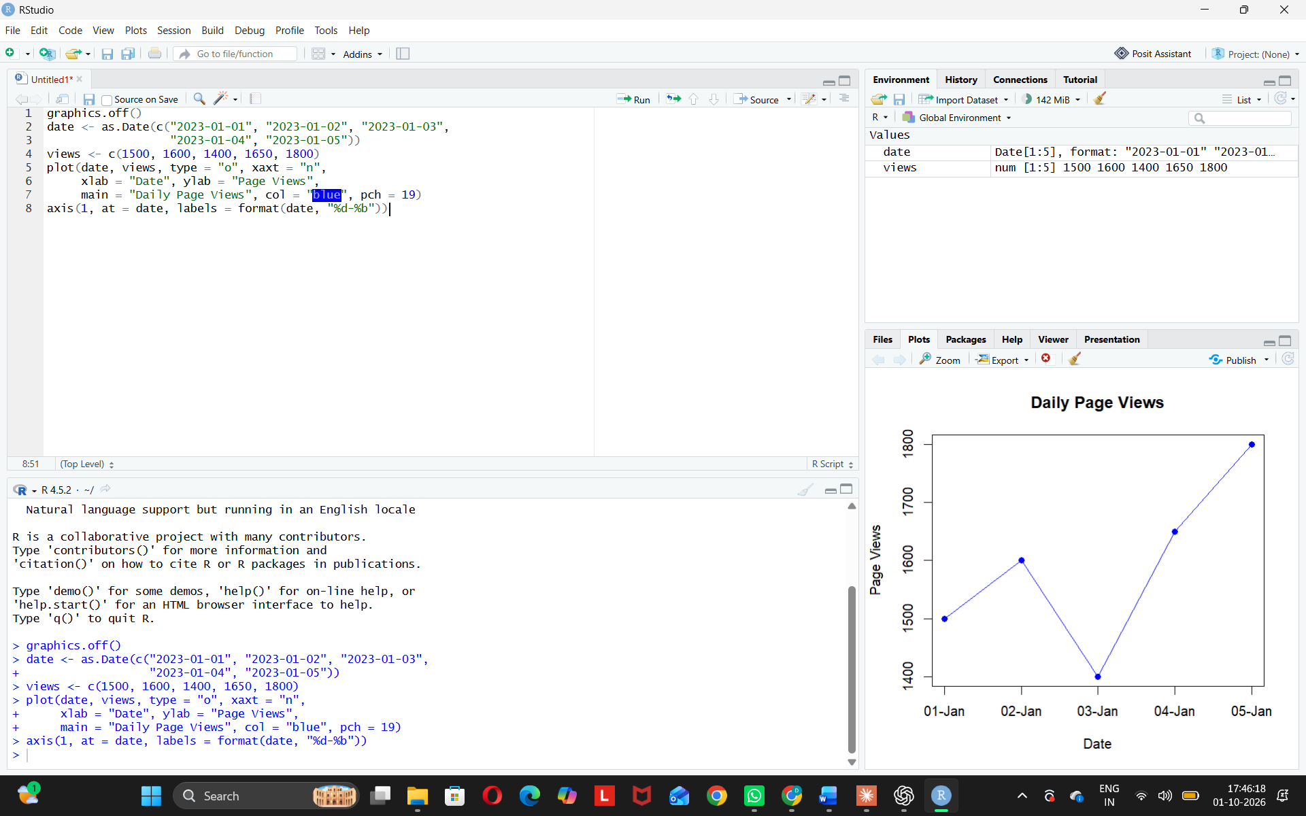
Observation: Page views dip on 3rd Jan and reach the highest (1800) on 5th Jan.
PROGRAM 2: Bar Chart (Top 3 Days by Click-through Rate)
Aim: To show the top N days with the highest click-through rates.
graphics.off()
date <- c("01-Jan", "02-Jan", "03-Jan", "04-Jan", "05-Jan")

ctr <- c(2.3, 2.7, 2.0, 2.4, 2.6)

N <- 3
top <- order(ctr, decreasing = TRUE)[1:N]

barplot(ctr[top], names.arg = date[top],
xlab = "Date", ylab = "Click-through Rate (%)",
main = "Top 3 Days by Click-through Rate",
col = "orange", ylim = c(0, 3))
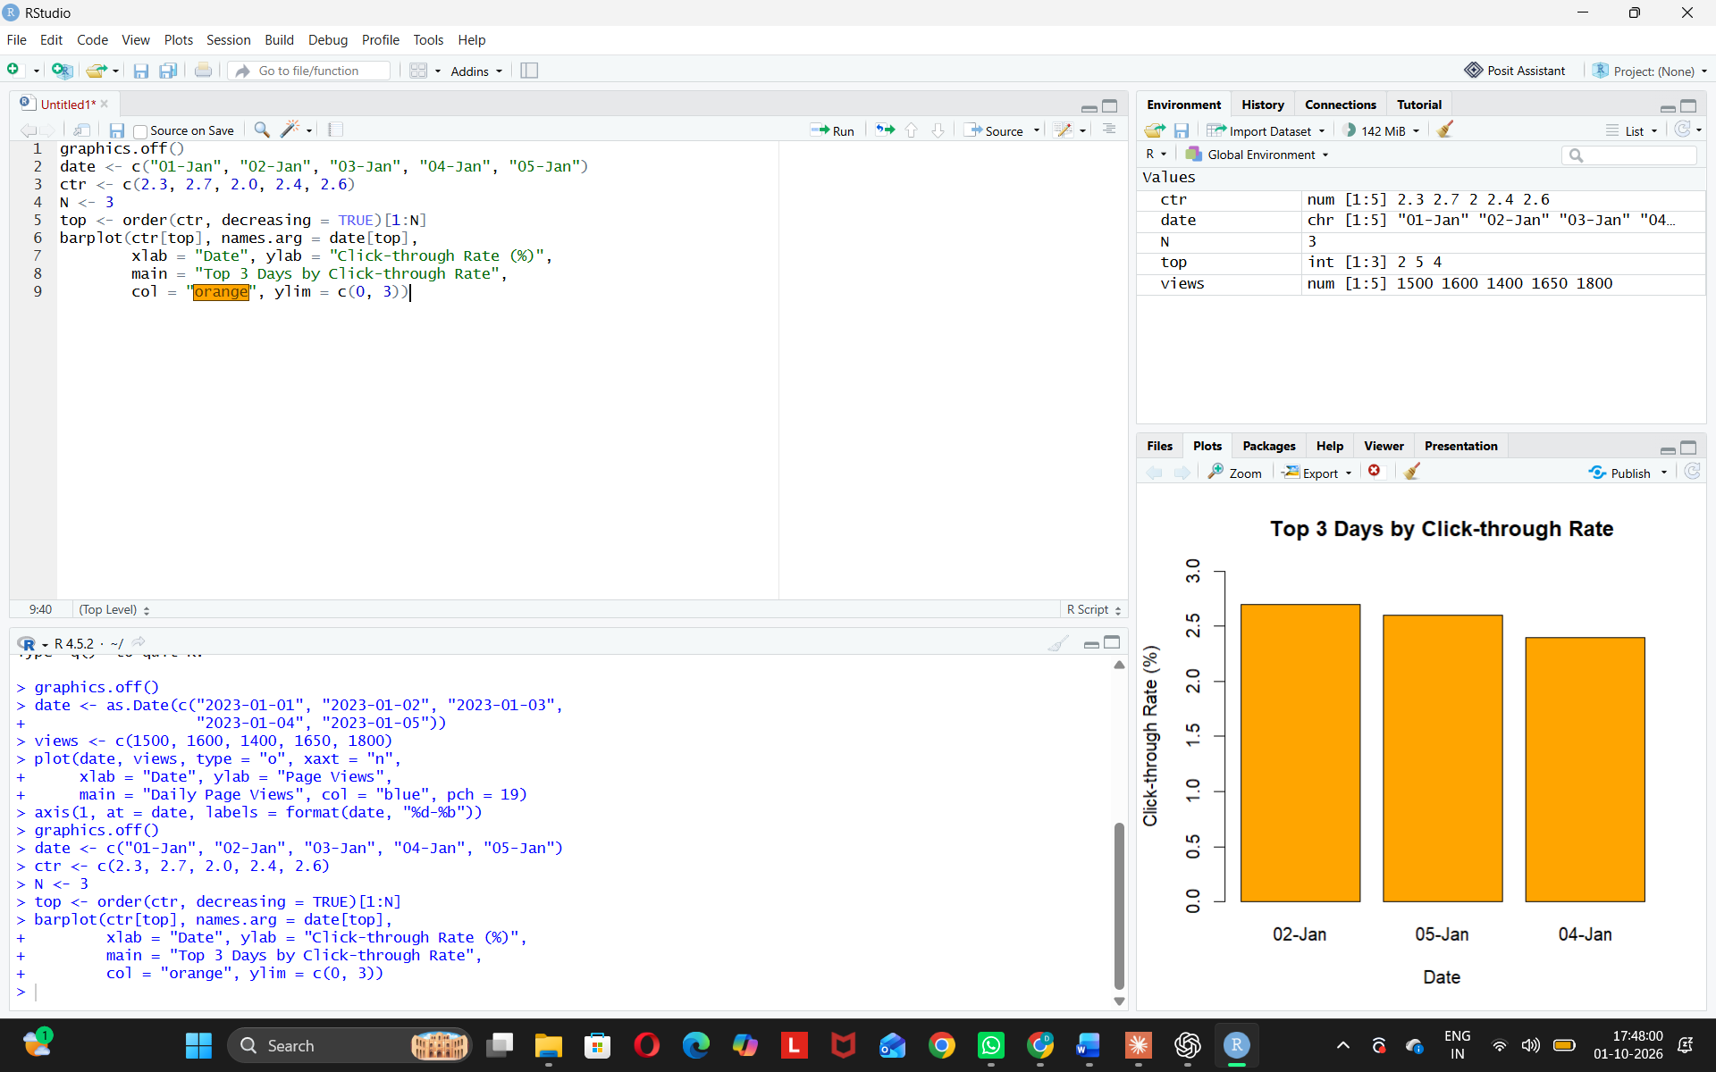
Observation: 2nd Jan has the best click-through rate. 3rd Jan (2.0%) is the lowest, so it is not in the top 3.
PROGRAM 3: Stacked Area Chart (User Interactions)
Aim: To show the distribution of likes, shares, and comments over time.
install.packages("ggplot2") # run only once
library(ggplot2)
graphics.off()
date <- as.Date(c("2023-01-01", "2023-01-02", "2023-01-03",
"2023-01-04", "2023-01-05"))
likes <- c(120, 150, 110, 160, 180)
shares <- c(40, 55, 35, 60, 70)
comments <- c(25, 30, 20, 35, 45)
df <- data.frame(
day = rep(date, 3),
type = rep(c("Likes", "Shares", "Comments"), each = 5),
count = c(likes, shares, comments)
)
ggplot(df, aes(x = day, y = count, fill = type)) +
geom_area() +
labs(x = "Date", y = "Number of Interactions",
title = "User Interactions on Website", fill = "Interaction")
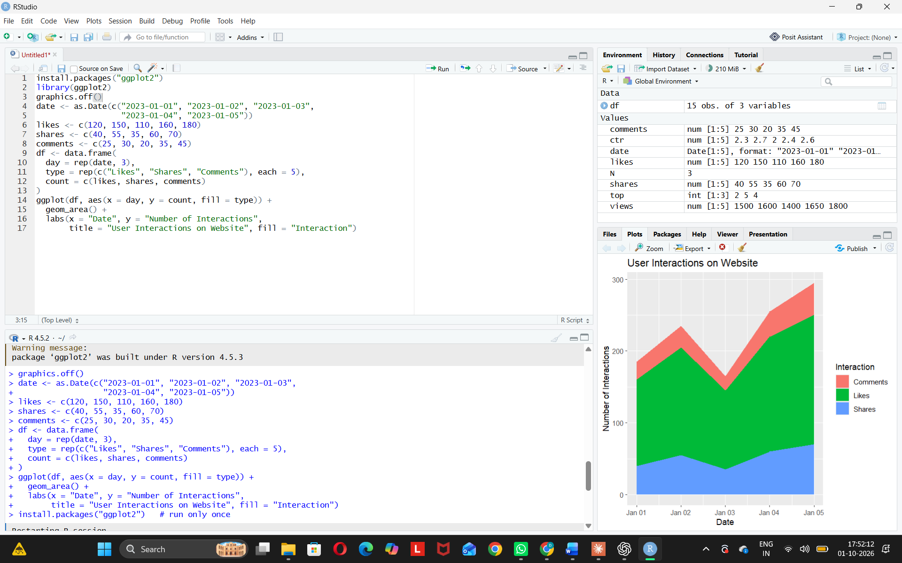
Observation: Interactions are highest on 5th Jan. Most users like, fewer share, and the fewest comment.
PROGRAM 4: Tableau Dashboard
Aim: To build an interactive dashboard with the line chart and bar chart in Tableau.
Steps in Tableau
- Save the website traffic data (Date, Page Views, Click-through Rate) as an Excel or CSV file.
- Open Tableau and connect to the file using Connect > Microsoft Excel / Text file. Make sure Date has the Date data type.
- Sheet 1 (Line Chart): Drag Date to Columns (set to Day, continuous) and Page Views to Rows (SUM). Add PageViews to Label and rename the sheet "Daily Page Views".
- Createa parameter named "Top N"(Integer, value 3, range 1 to 5) and show the parameter control.
- . Sheet 2(Bar Chart): Drag Date (Day, discrete) to Columns and Click-through Rate to Rows (AVG). Rightclick Date > Filter > Top, choose "By field", and set the value to the Top N parameter by Click-through Rate. Sort the bars in descending order and rename the sheet "Top N Days by CTR".
- Create a new Dashboard (Dashboard > New Dashboard). Set the size to Automatic and drag both sheets onto the dashboard area.
- Add interactivity: select each chart and click Use as Filter, so selecting a date in one chart filters the other chart. Add a Date range filter (Show Filter > Apply to Worksheets > Selected Worksheets).
- Add the title "Website Traffic Dashboard", keep the Top N control visible, and test the dashboard in Presentation Mode.
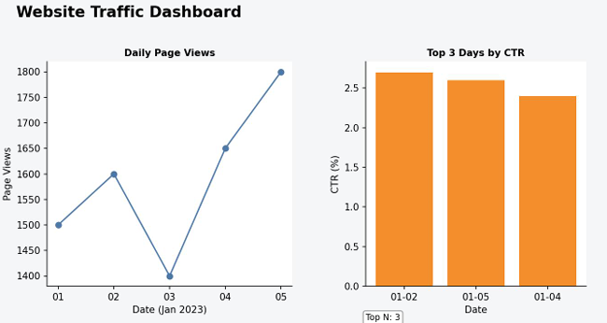
Observation:
The dashboard shows the page view trend and the top days by click-through rate side by side. Users can change the Top N value, select a date range, or click a point or bar to see how page views and click-through rate relate for a particular day.
Procedure
1. Define the date, page views and click-through rate vectors in R, converting the dates with as.Date().
2. Use the plot() function with type = "o" to create the line chart of daily page views, and axis() to label the dates.
3. Sort the data with order() and select the top N rows using head(), then use barplot() to create the bar chart.
4. Create a long-format data frame of likes, shares and comments, and use ggplot2 with geom_area() to draw the stacked area chart.
5. Loadthewebsite traffic file into Tableau and build the line chart and top N bar chart worksheets.
6. Combinebothworksheets in a Tableau dashboard and add the Top N parameter, filters and actions for interactivity.
RESULT:
The website traffic data was successfully visualized using a line chart, a bar chart and a stacked area chart in R. An interactive Tableau dashboard was also created, combining the line chart and the top N bar chart so that users can explore page views and click-through rates.

